51. Basics of LWC - 14 Nov 2022

Today we will learn:

Lightning Frameworks

1] Aura Framework

2] LWC Framework

**LWC = Lightning Web Component**

**What are Lightning Web Components?**

LWC is a new programming model to develop Salesforce lightning components. It’s a UI (**USER INTERFACE**) framework that is built using native HTML and modern JavaScript. It uses core *web component*standards and leverages custom elements, templates, decorators, modules, shadow DOM, and other new language constructs available in ECMAScript 7 and beyond.

OR

LWC is the combination of HTML, Java Script and some Apex Code and it is a UI Framework (User Interface). It is the advanced version of Aura Lightning.

Frontend VS Backend

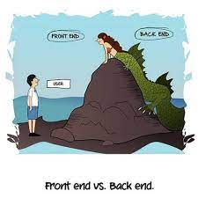

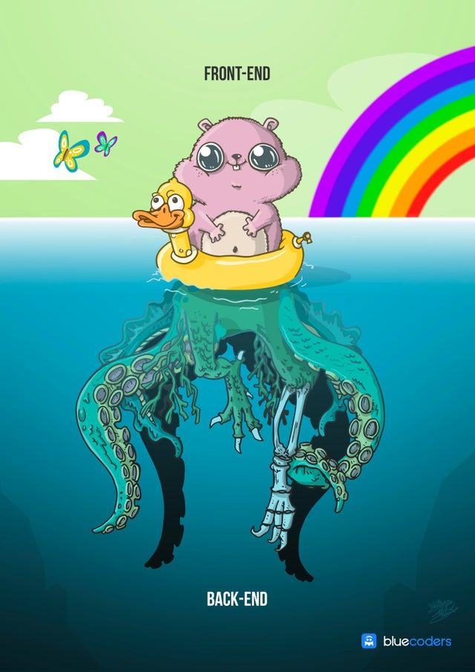

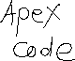

User Story 1] Create a new “Hello World” LWC Component.

Install VS Code: https://www.youtube.com/watch?v=MDCxG-vfx0E



To Open a Command Pallet 🡺 CTRL + SHIFT +P

1] Create a New Project:

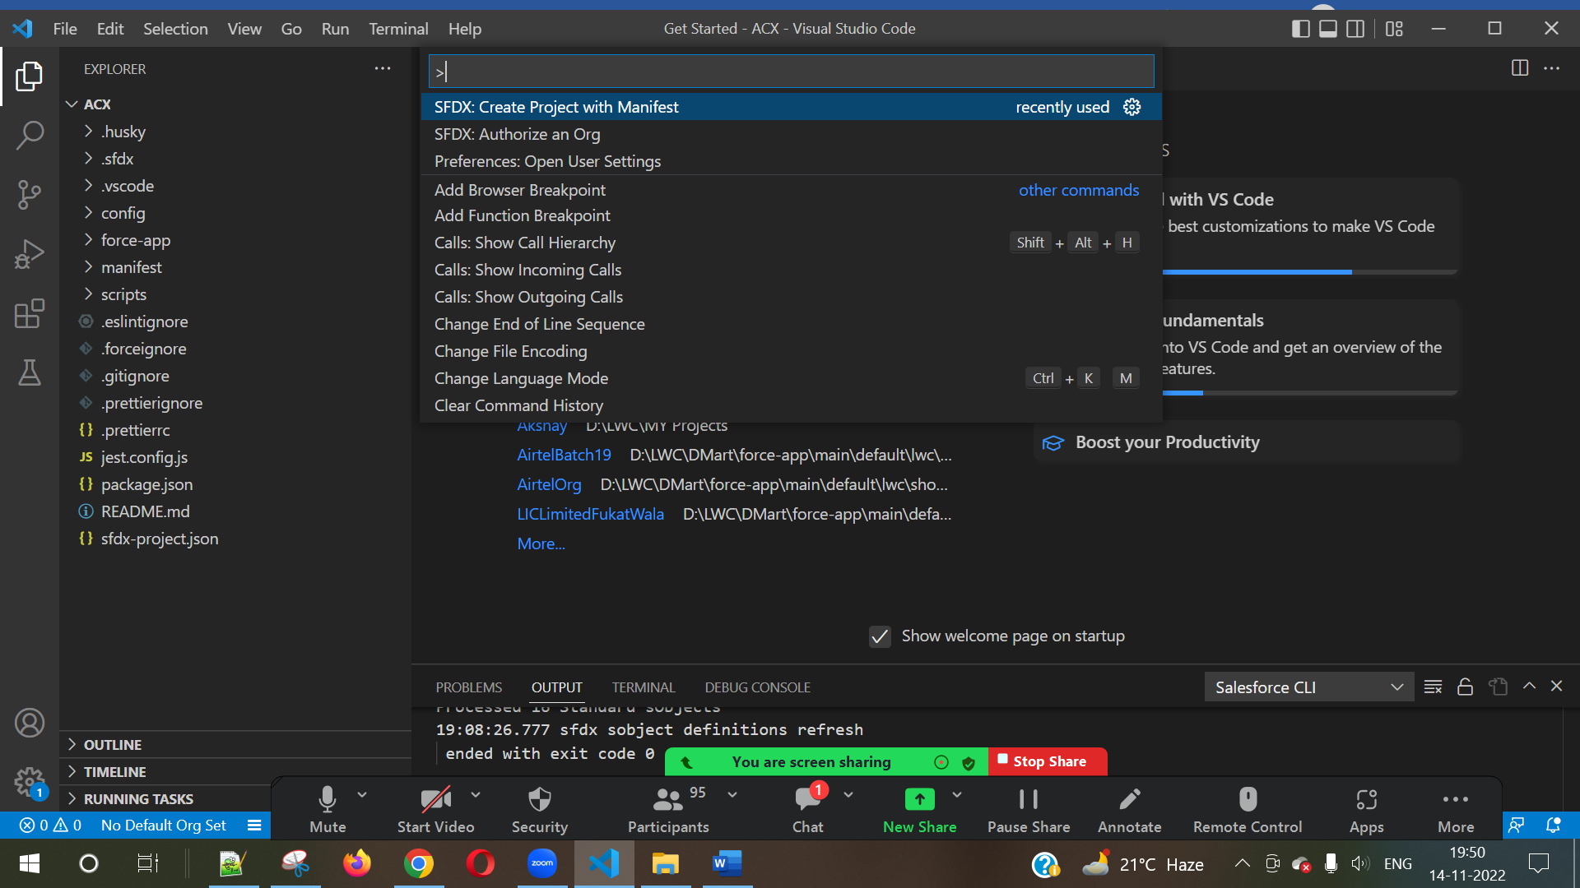



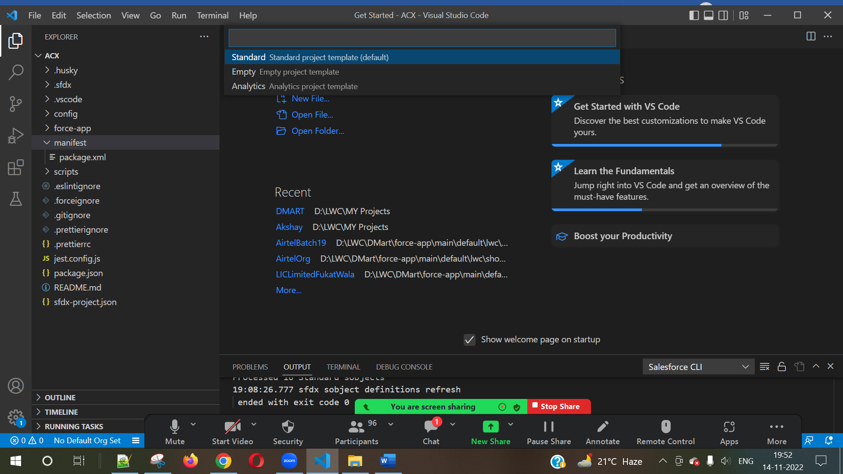

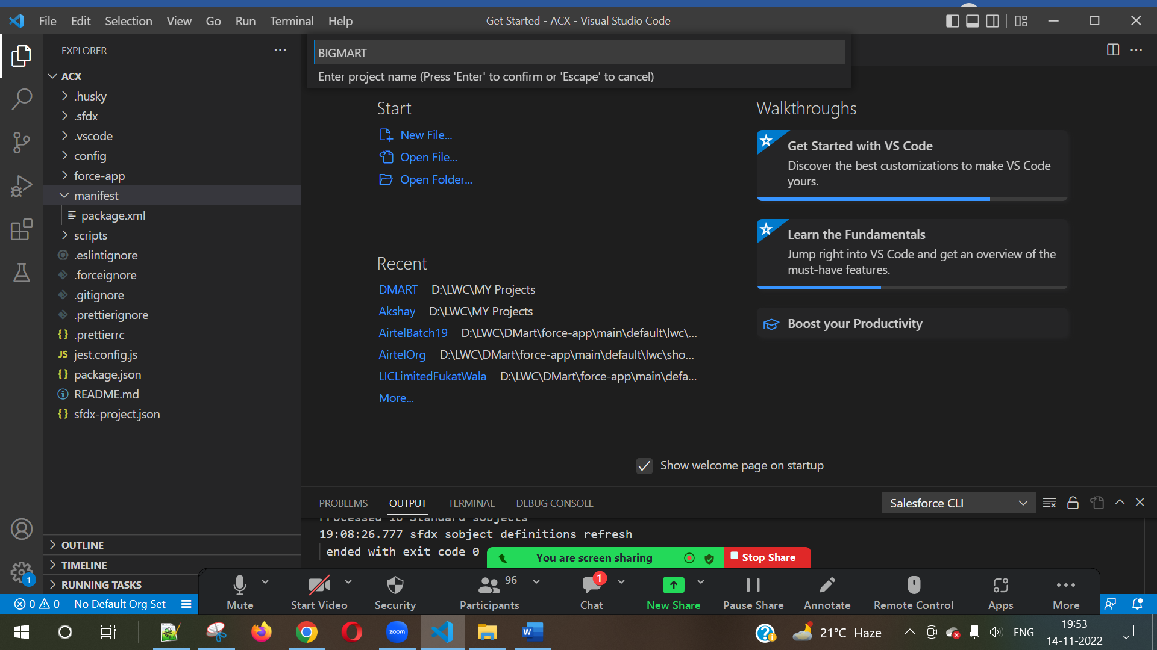



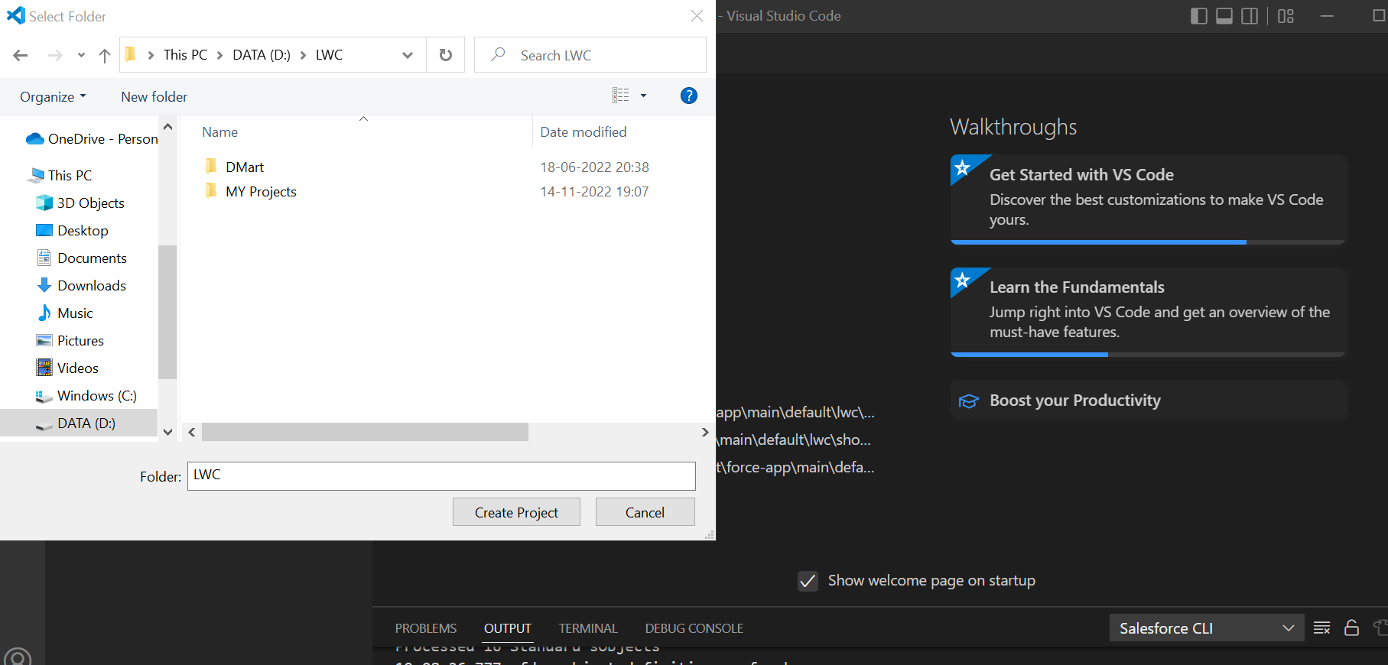

2] Now Connect VS Code Project with SFDC ORG.



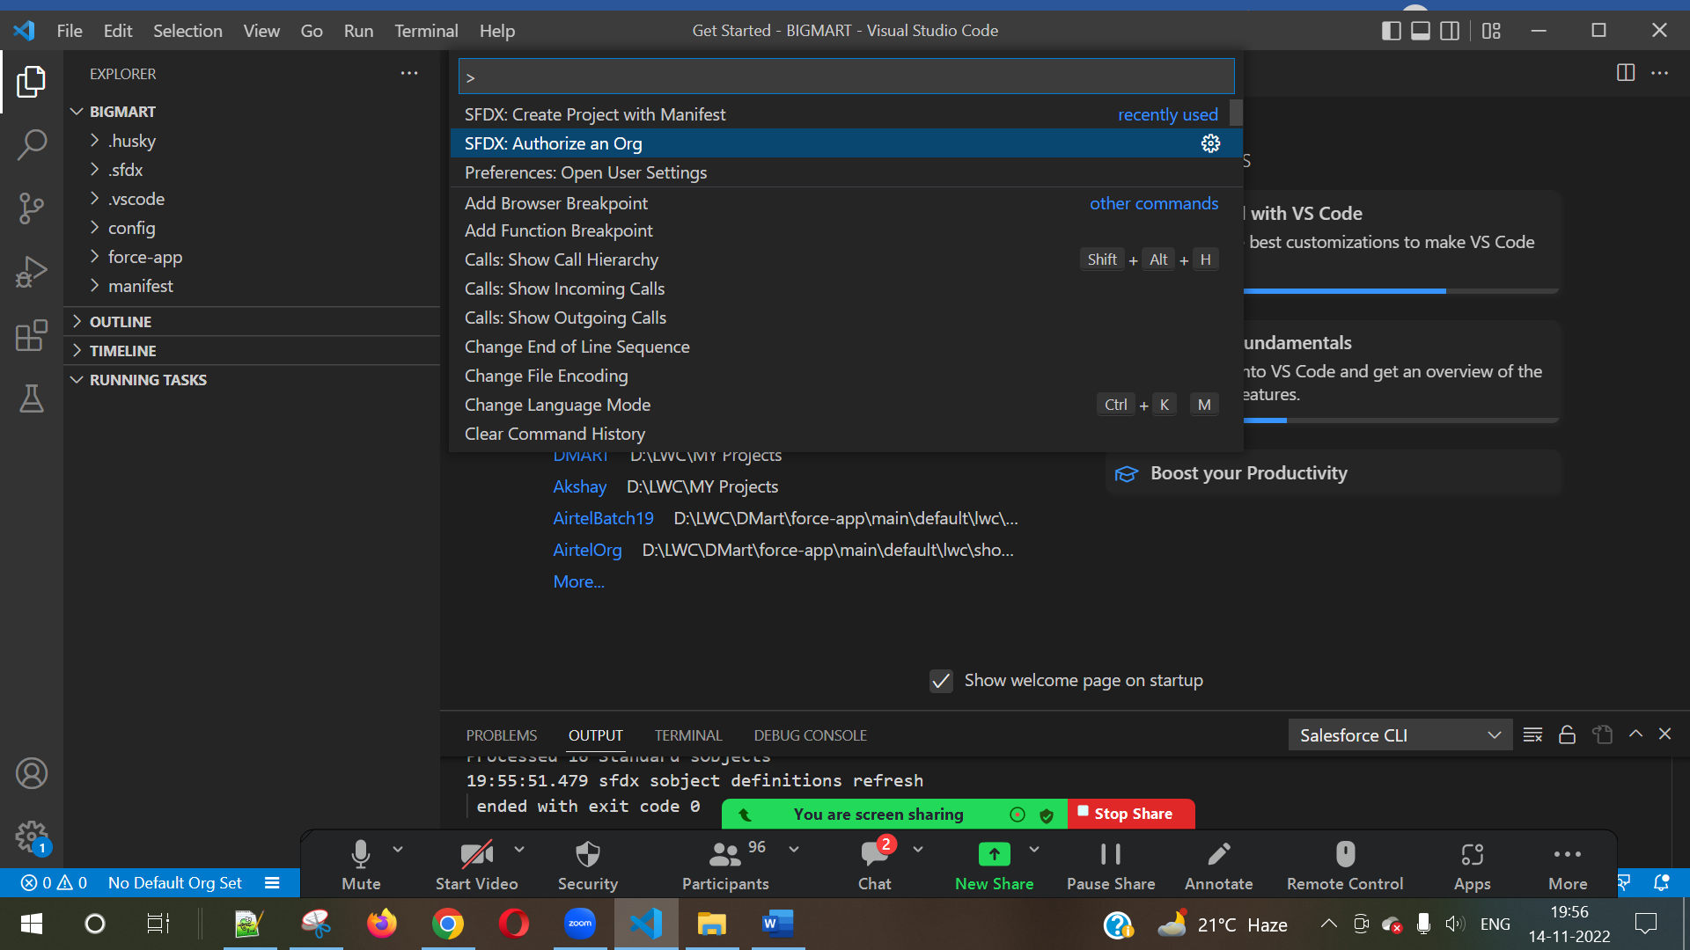

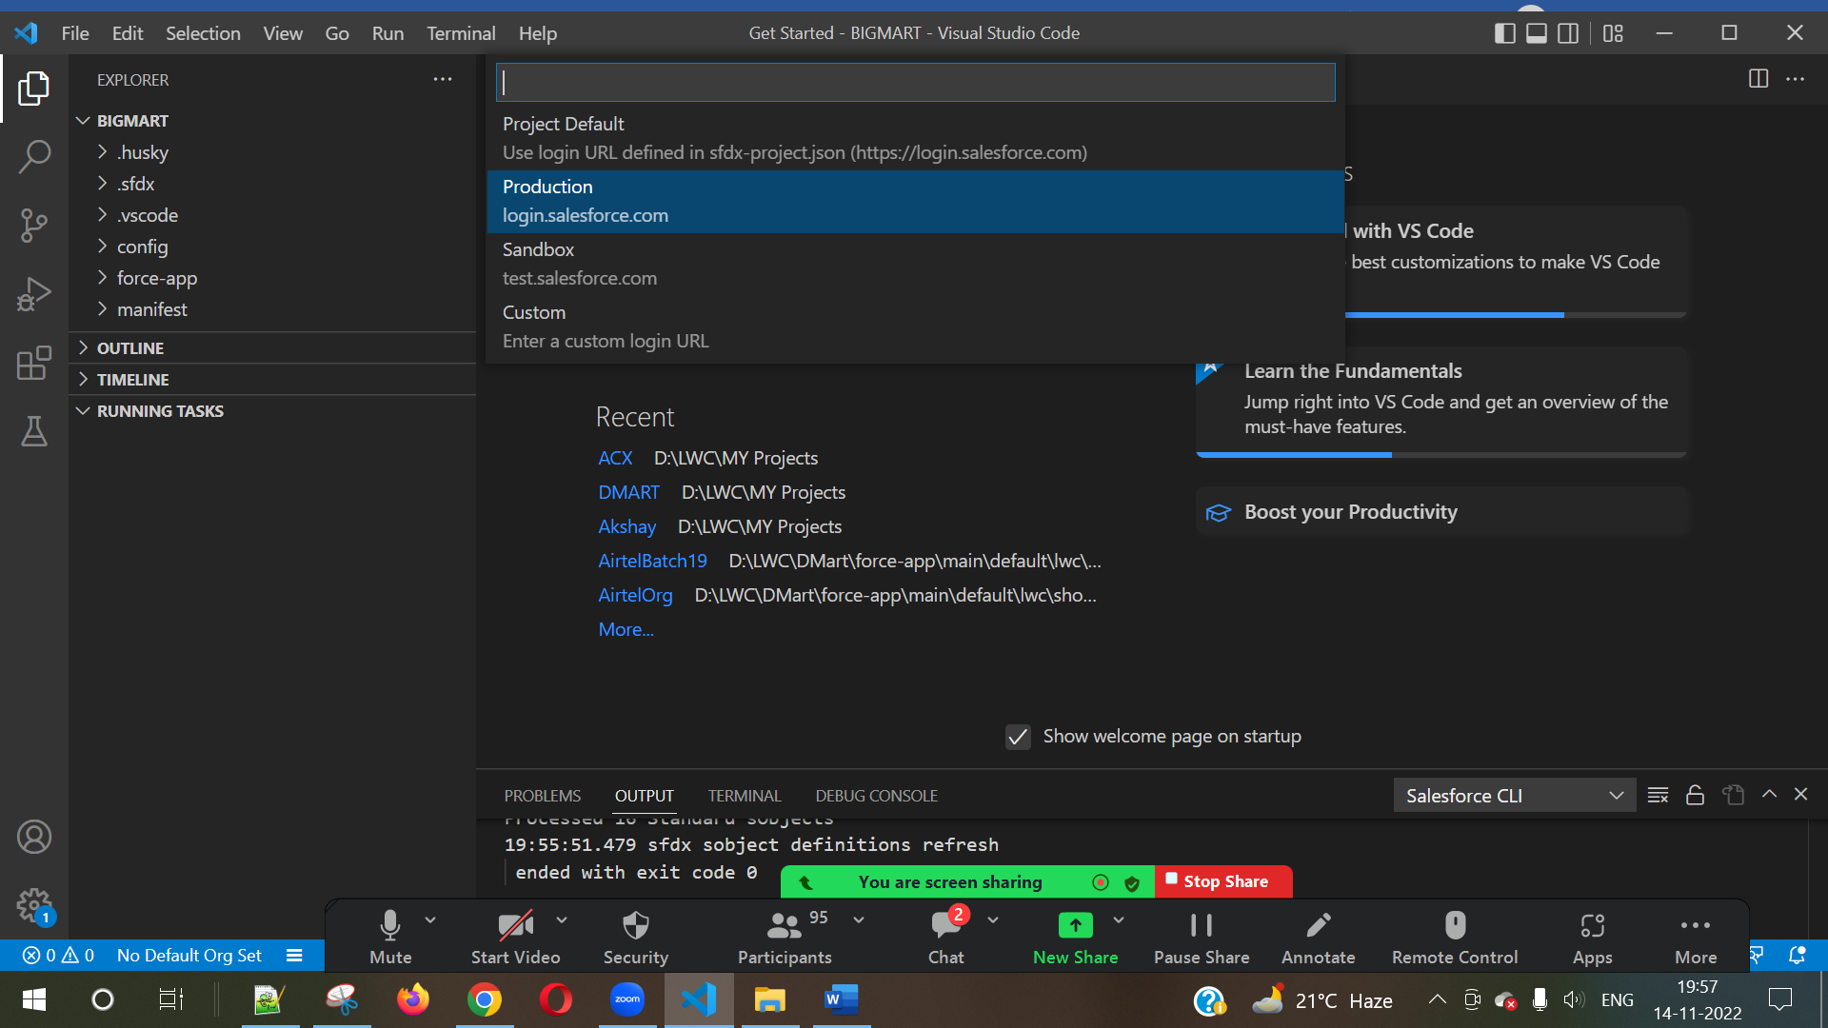

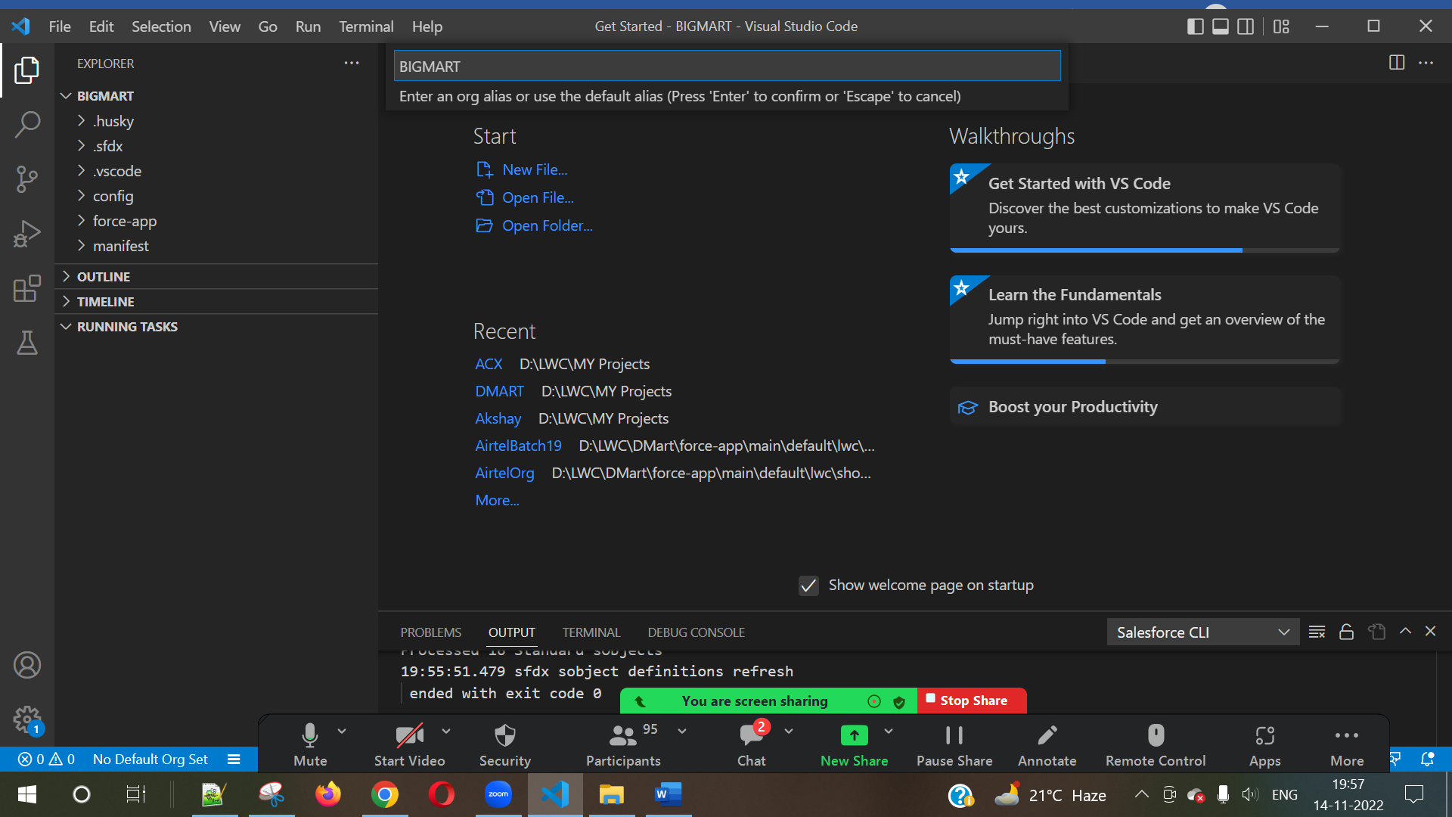



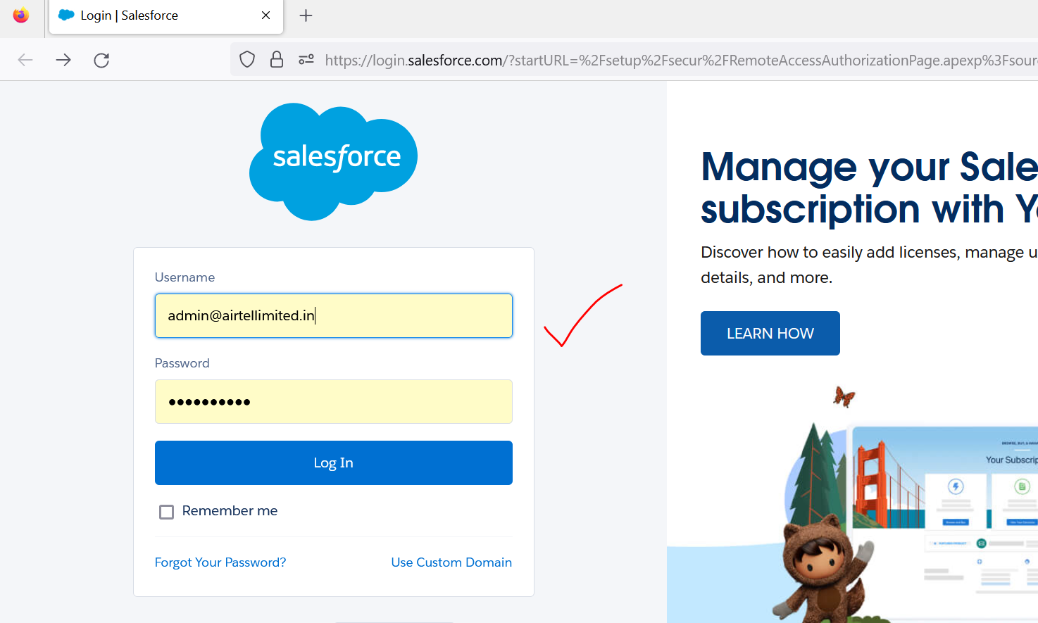

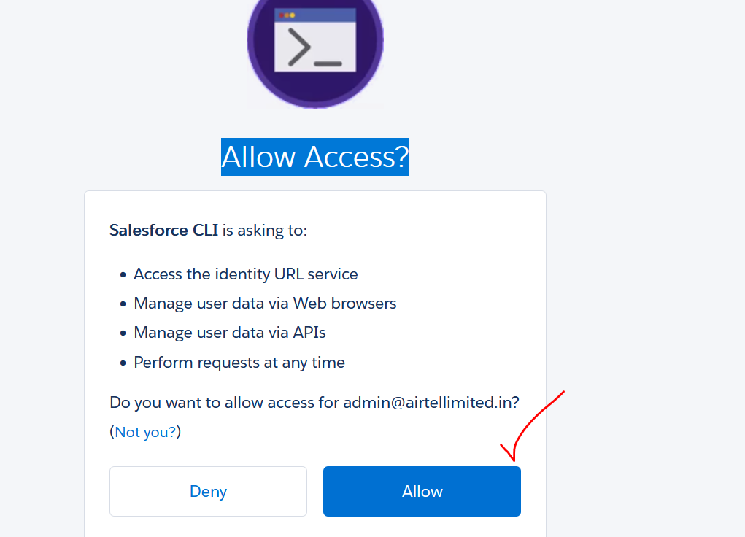

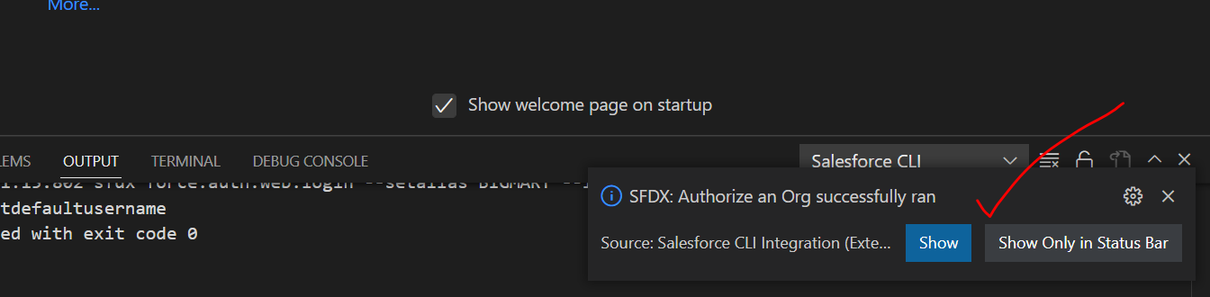

3] Retrieve Components from SFDC Org to VS Code

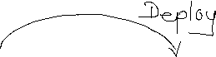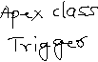

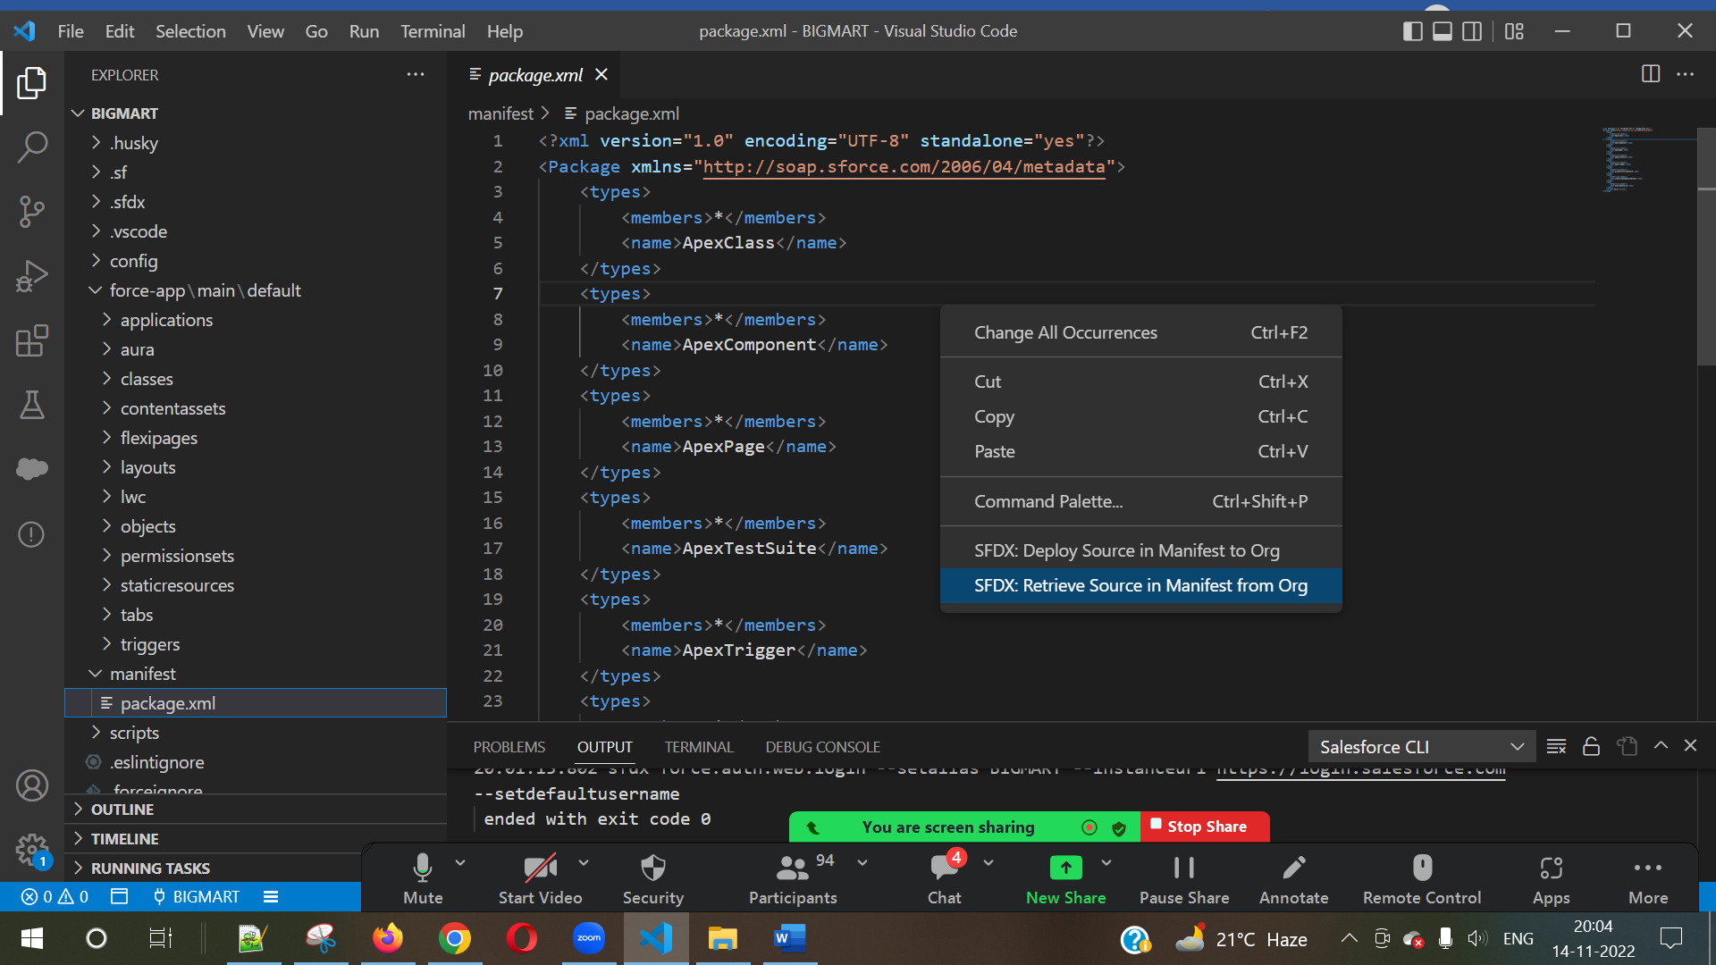



NOTE – If Retrieve Operation Fails, then Update sfdx

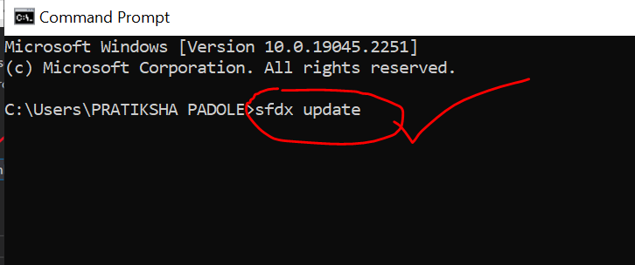

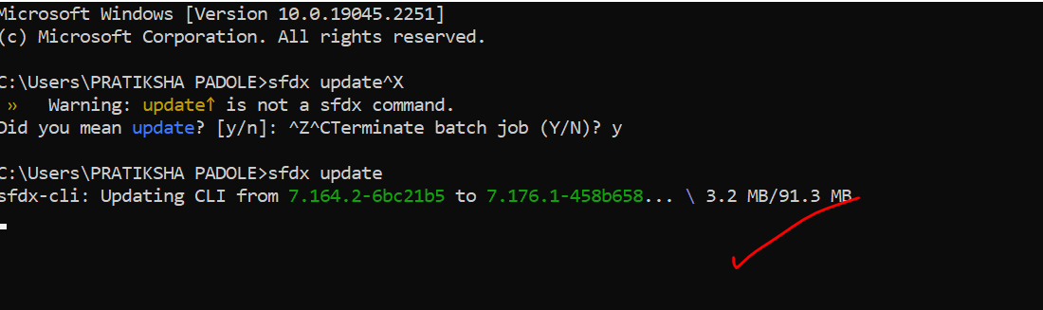

4] Now Create a New LWC COMPONENT “HelloWorld”.

Naming Conventions for LWC Component.

|  |  |
| --- | --- |
| Hello | hello |
| HelloWorld | helloWorld |
| Display | display |
| AatiKyaKhandala | aatiKyaKhandala |
| MyCarComponent | myCarComponent |
| mybusinesscomponent | myBusinessComponent |

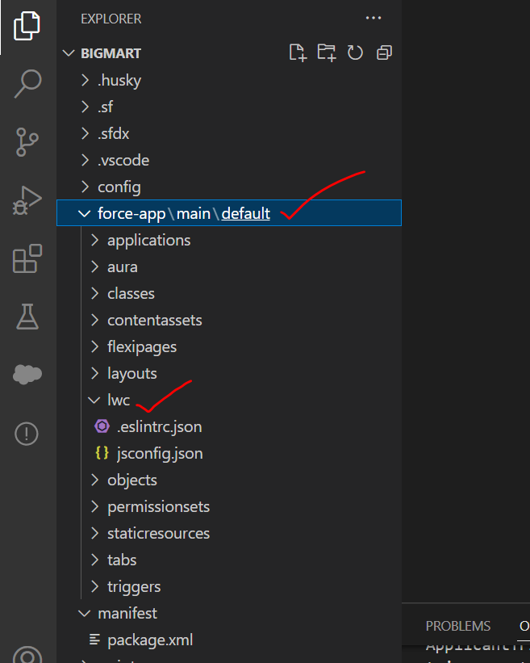



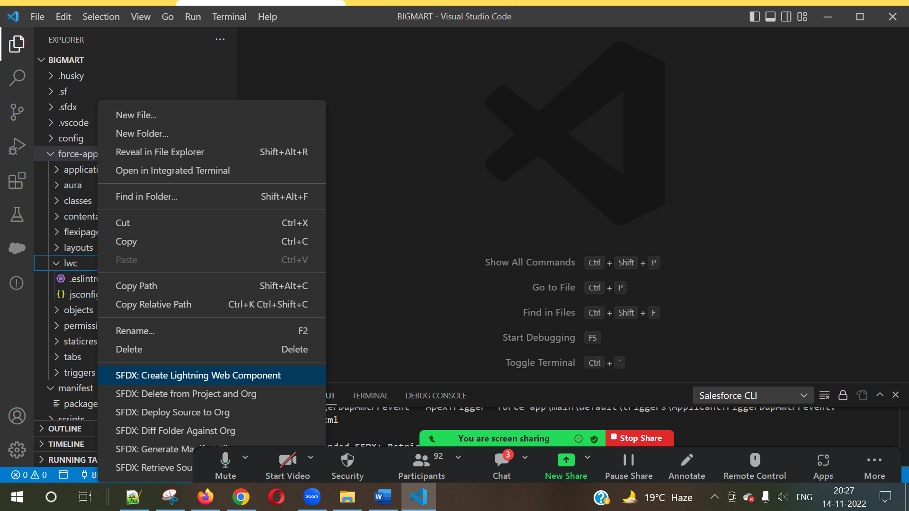

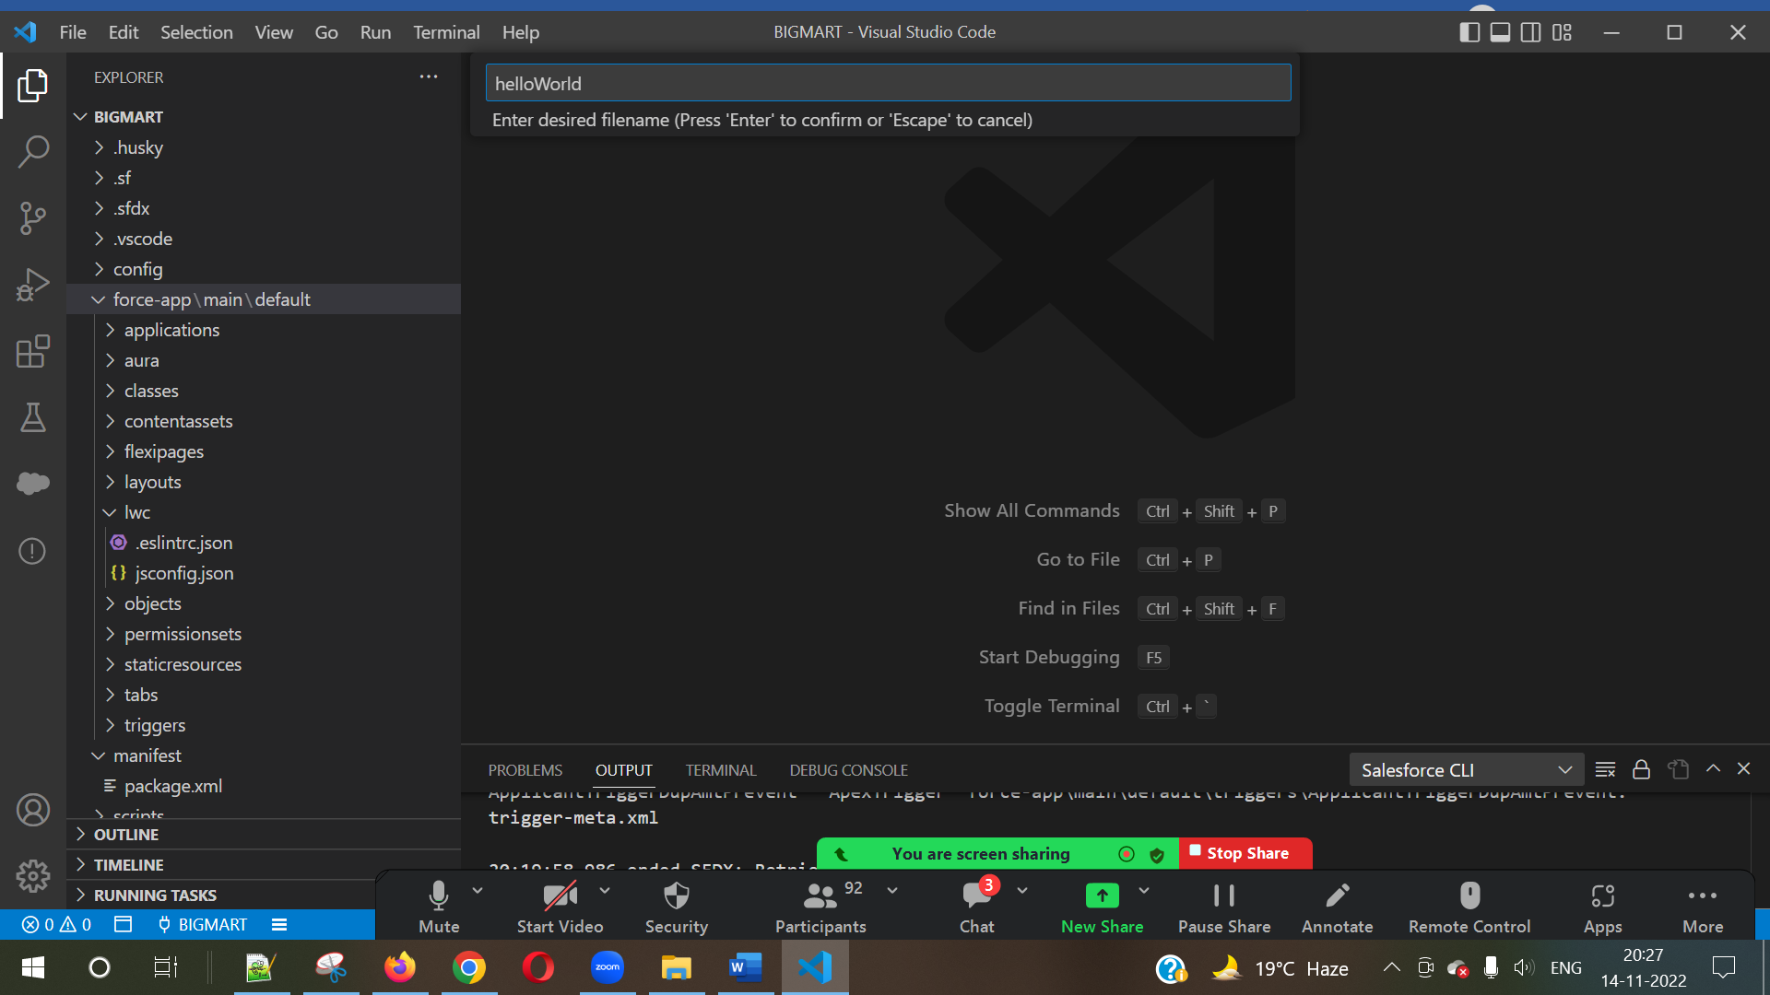



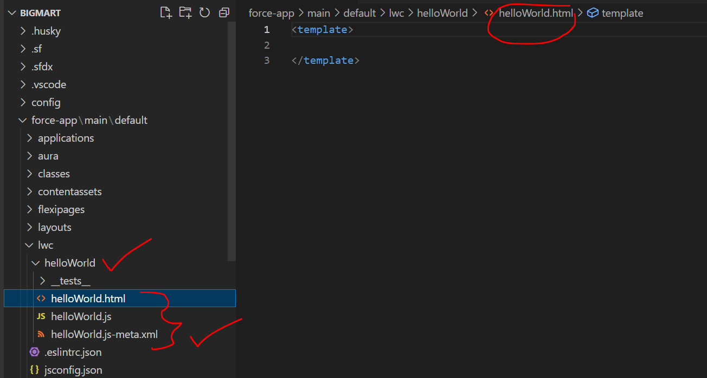

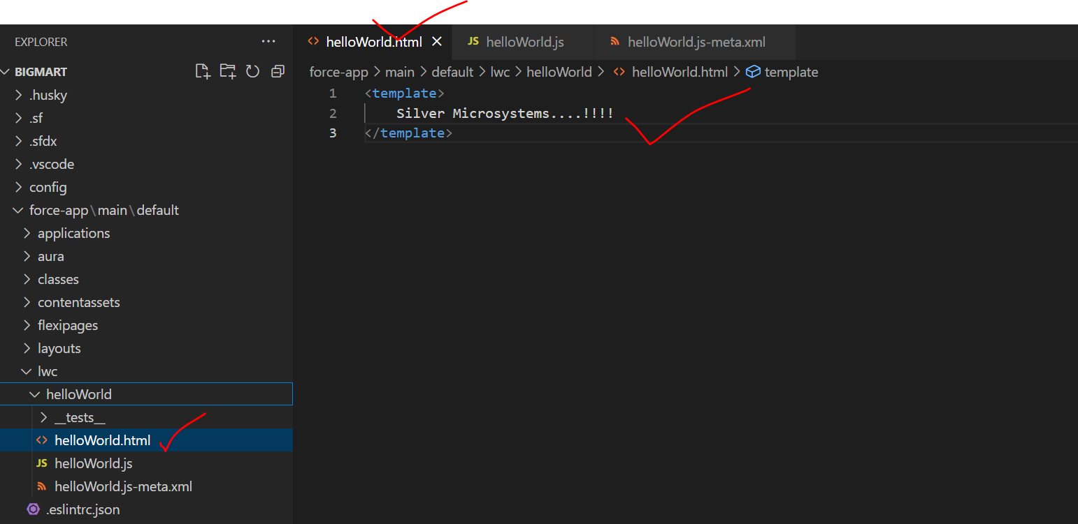

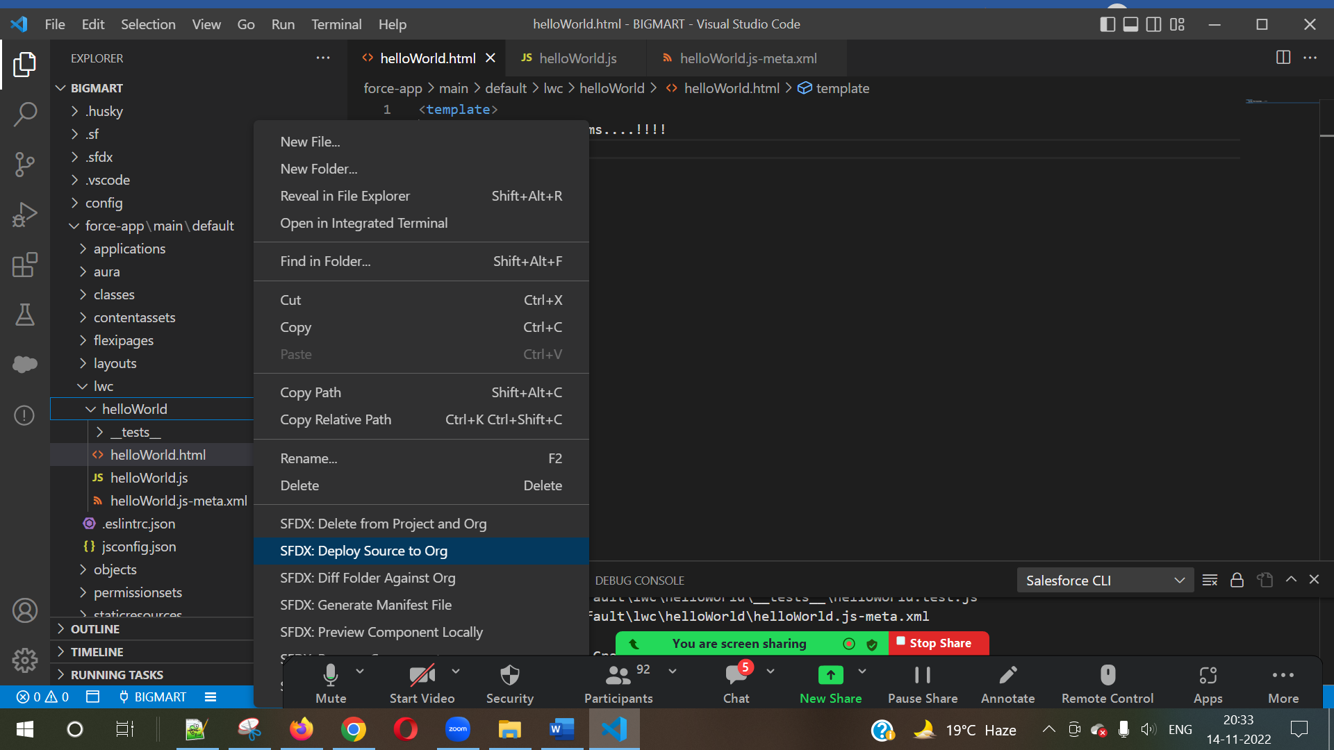

Show LWC Component in SFDC ORG:

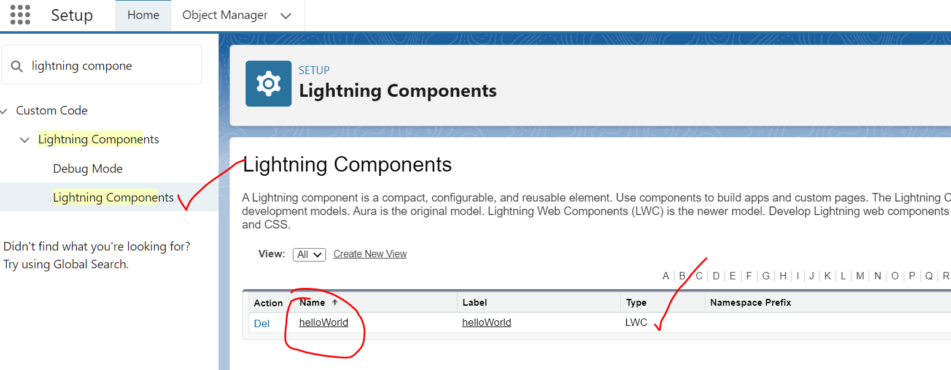

**Usage of LWC Component**

* App Page
* Details Page
* Utility Bar
* Home Page
* Quick Action Button
* Tab
* Community

|  |  |
| --- | --- |
| **Usage** | **Targets** |
| Details Page | lightning__RecordPage |
| App Page | lightning__AppPage |
| Utility Bar/Item | lightning__UtilityBar |
| Home Page | lightning__HomePage |
| Quick Action Button | lightning__RecordAction |
| Community | lightningCommunity__Page |
| Tab | lightning__Tab |

* App Page

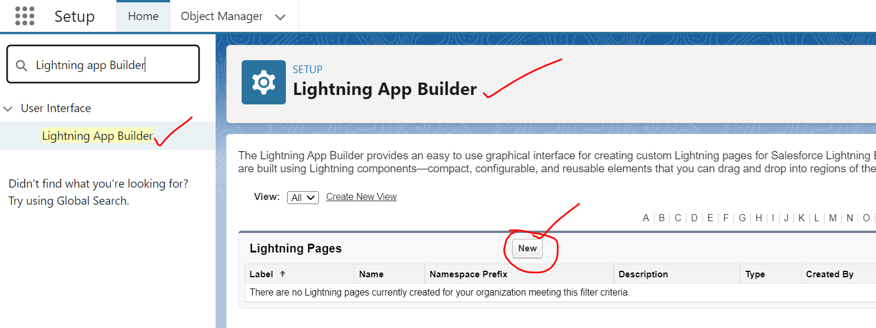

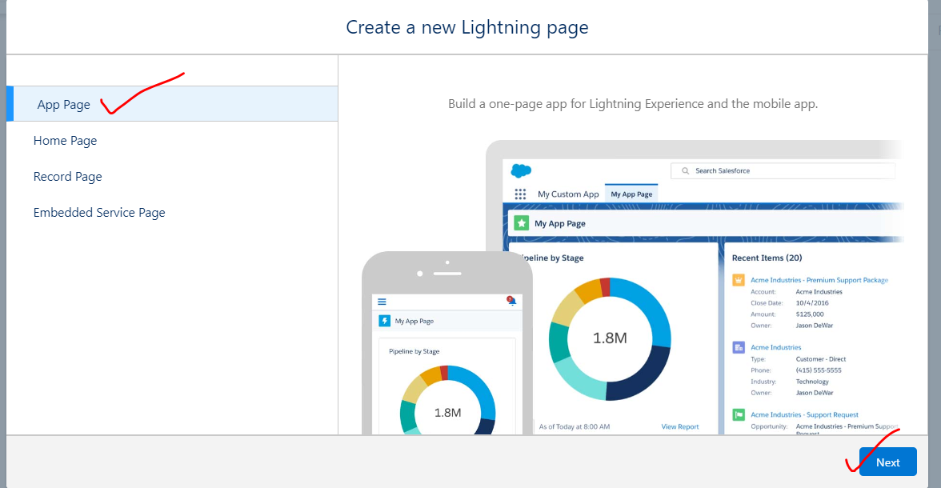

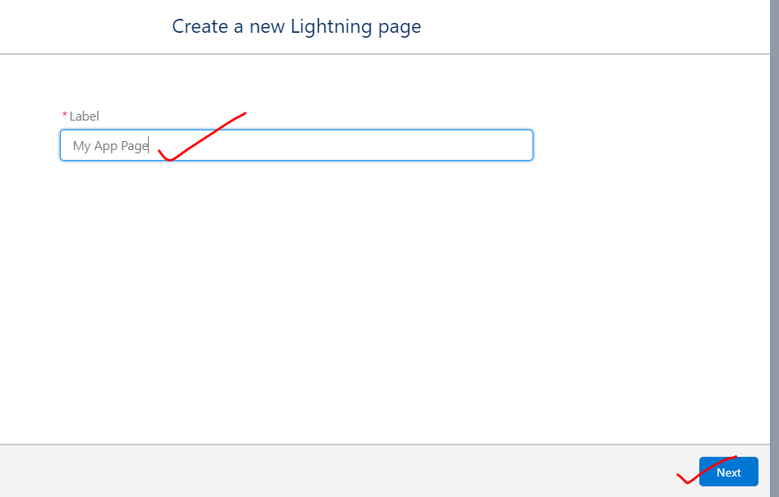

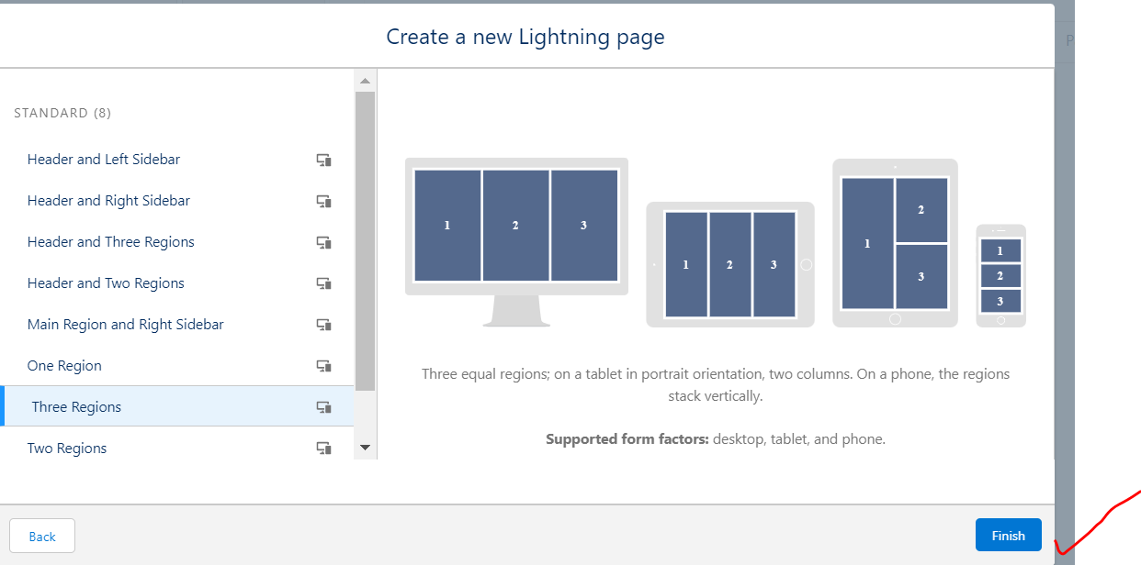

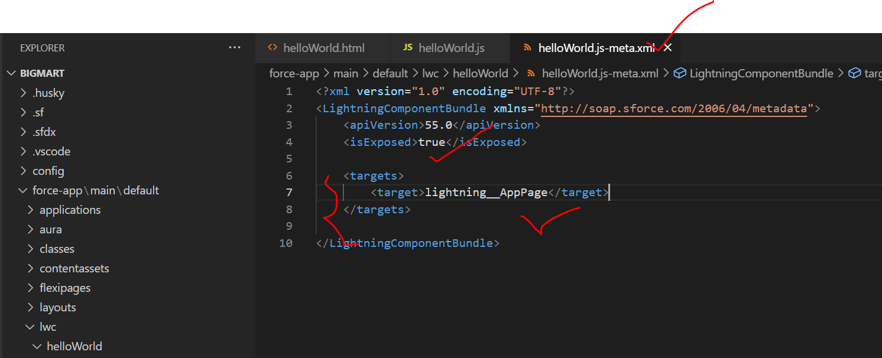

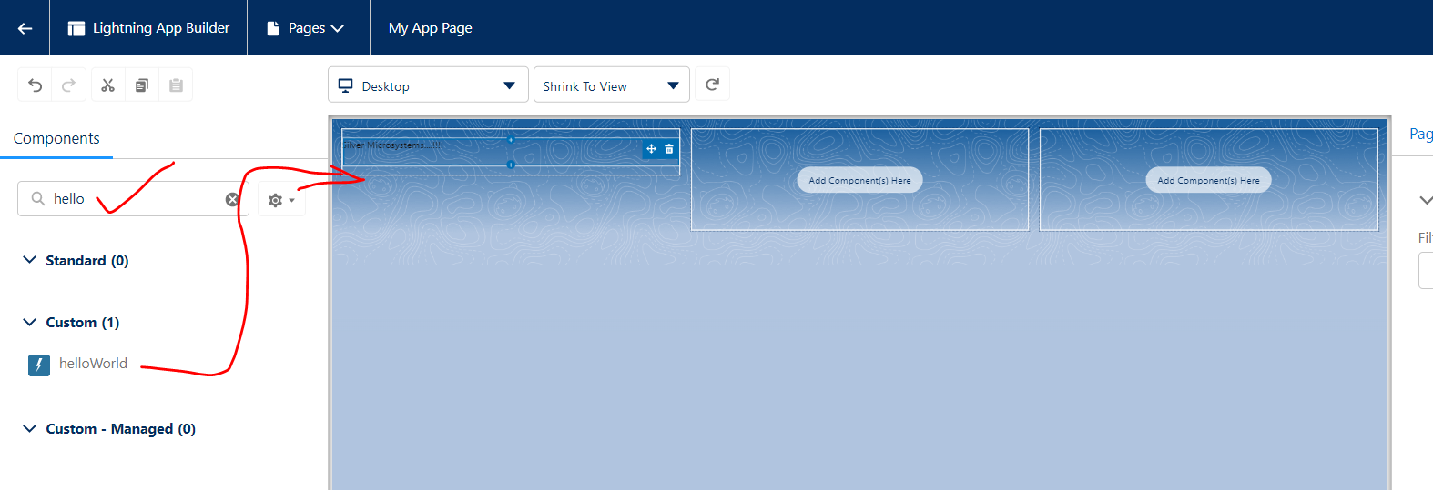

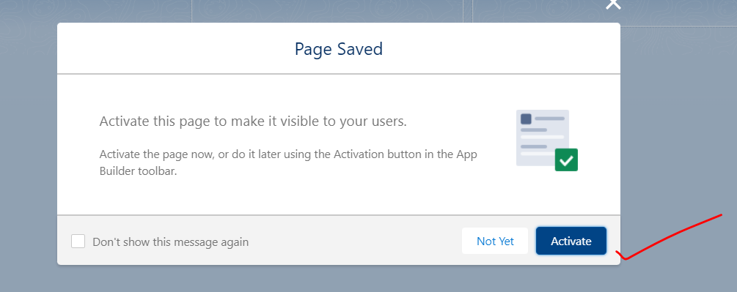

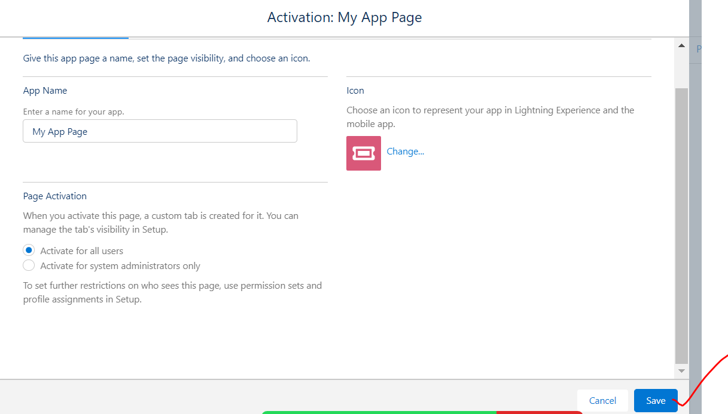

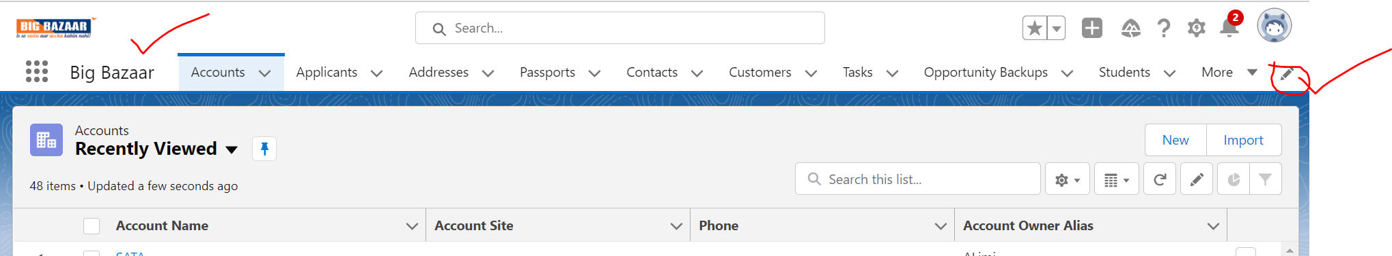

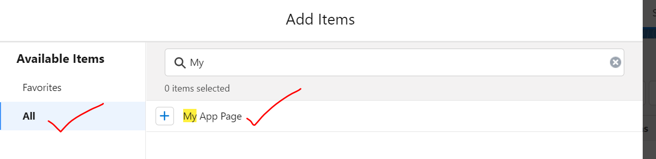

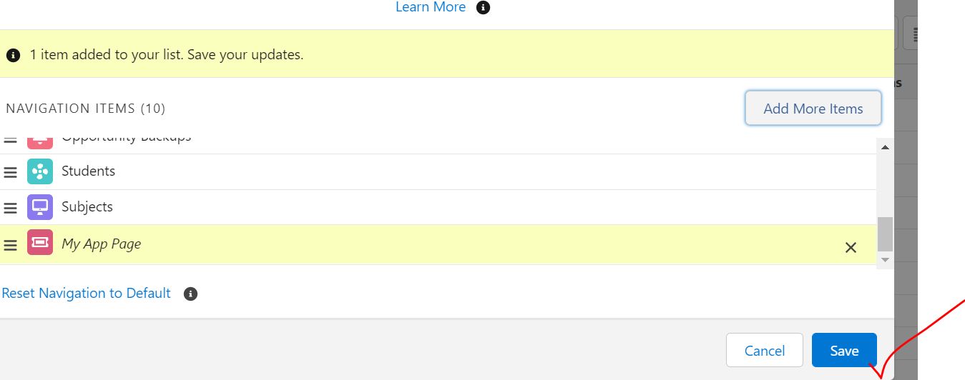

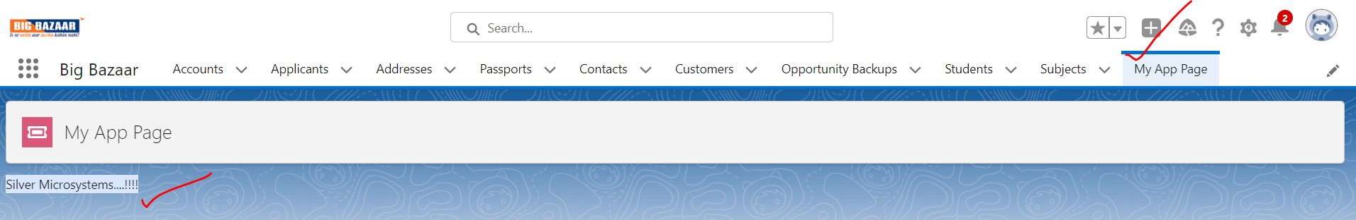

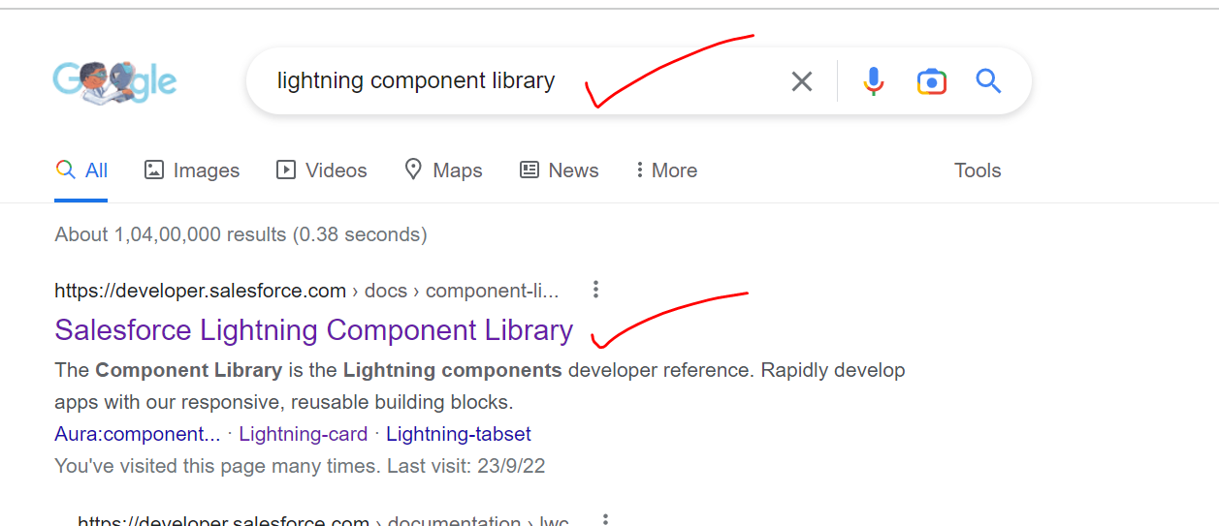

<https://developer.salesforce.com/docs/component-library>

CARD:

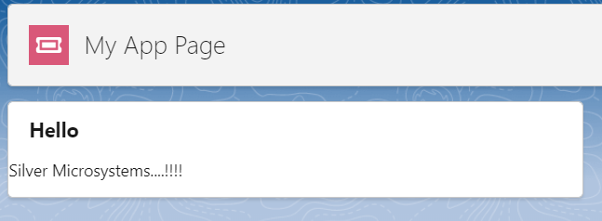

HTML:

<template>

    <lightning-card  title="Hello">

            Silver Microsystems....!!!!

    </lightning-card>

</template>

JS File:

import { LightningElement } from 'lwc';

export default class HelloWorld extends LightningElement {}

Meta.xml File

<?xml version="1.0" encoding="UTF-8"?>

<LightningComponentBundle xmlns="http://soap.sforce.com/2006/04/metadata">

    <apiVersion>55.0</apiVersion>

    <isExposed>true</isExposed>

    <targets>

        <target>lightning__AppPage</target>

    </targets>

</LightningComponentBundle>

===================END===============

* Details Page
* Utility Bar
* Home Page
* Quick Action Button
* Tab
* Community